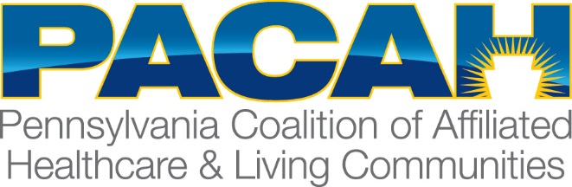

PACAH FISCAL OFFICERS GROUP
April 25, 2018
12:00 p.m.
Presidents Hall I
The Penn Stater Hotel and Conference Center

1. Welcome & Introductions – Ed Frigo, Chairperson

2. Approval of December 19, 2018 Meeting Minutes –

3. OLTL Discussion – Peggy Morningstar, Chief Financial Officer/Director of Finance, OLTL; Judy Patrick, Policy Manager, OLTL

- CHC
  - Update on SW implementation –
    - How is it going?
    - Any issues?
    - Claims being processed/paid
    - Transportation issues
  - Update on SE implementation
    - Timeframe
    - Informational sessions
    - Any changes
    - Should they begin contracting?
    - Rates – is there still a rate floor; are DSH, Vent and Trach, HAI and all other supplemental payments included?
    - How will App. IV payments be made
- 17-18 Assessment Update (both FFS and CHC)
  - Important dates
  - Update to end user manual
  - Timing of payments
  - Penalties and Interest
- 18-19 Assessment update
- 17-18 IGT Update
  - Timeline
  - Payments (CHC and FFS)
- 18-19 IGT update
- Non-public MDOI payment 17-18 and 18-19
- 18-19 Budget status
- 17-18 Finalized rate payments
- CPE Grant Status

4. Questions?

5. PACAH Update (if time allows)

